Virtual Node Administrator’s Guide
08/6/2014

This document provides basic instructions for managing virtual node using the Virtual Node Administrative Platform (VNAP).

Revision History
Change Record
Version Number | Description of Change | Change  Effective Date | Change  Entered By
1.0.00 | Initial Draft | January 16, 2013 | Dr. Yunhao Zhang
2.0.00 | Updated with Workflow information in Appendix | February 20, 2013 | Dr. Yunhao Zhang
3.0.00 | Editorial Review and Update | April 23,2013 | Chris Clark
3.0.10 | Revised Data Source Management section and added Virtual Node Connector configuration options. | May 15, 2014 | Dr. Yunhao Zhang
4.0 | Editorial Review and Update | August 8, 2014 | Chris Clark
4.0.0.1 | Updated with New Workflow information in Appendix. Rebuilt Table of Contents. | October 21, 2014 | Peter Gu

Table of Contents
1 Introduction 4
1.1 What is a Virtual Node? 4
1.2 Virtual Node Features 4
1.3 Virtual Node Security 5
1.4 Major Objects in a Virtual Node 5
2 Inheritance Model 6
2.1 Create a Virtual Node 7
2.2 Virtual Node Endpoints 8
2.3 Node Owners and Dataflow Administrators 9
3 Data Source Management 10
3.1 Network Connectivity Options 10
3.2 Create Data Source 11
3.3 Data Source Security 12
4 Dataflow Management 13
5 Service Management 14
5.1 Create a Service 15
5.2 REST Interface 18
5.3 Clone Services 18
5.4 Publish Services 19
5.5 Update Services 20
6 Task Management 21
7 Document Headers 23
8 Transfer Files to Virtual Node 24
9 Appendix 25
9.1 Information Exchange Patterns and Common Workflows 25
9.1.1 Basic Submission Workflow 25
9.1.2 Generic Submission Workflow with Validation 26
9.1.3 Generic Query 27
9.1.4 Generic Query with ADO.Net 27
9.1.5 Local Query and Submit 28
9.1.6 Generic Solicit 29
9.1.7 Solicit and Download 29

Introduction

What is a Virtual Node?
Virtual node is a state of art Network Node implementation for the cloud environment, offered as a service (SaaS, Software as a Service). While the owner controls its security and functionalities, operations and maintenance will be supported by the hosting party.

A virtual node is a node that shares the physical implementation with other nodes while functioning distinctly with its own business process (dataflow and services), security controls and transaction isolations. In a cloud environment, a virtual node is deployed as a multi-tenant model.

From a theoretical point of view, the cost of hosting 1000 virtual nodes is almost equivalent to hosting one. The challenge of operating and maintaining hundreds of physical nodes on the Exchange Network could be minimized. The daunting task of deploying dataflows, or new services, to network nodes across dispersed geographic regions could be greatly simplified.

Virtual Node Features
- Simplicity: Virtual node drastically simplifies the development of dataflows. In most of the situations services can be created with a few button clicks.
- Maximize Sharing: Virtual node maximizes sharing of the node implementations and makes node readily available to all users and partners so that they can focus on building dataflows instead of network nodes.
- Simplify Management: All virtual nodes will be hosted in a centralized and managed environment to ensure the highest quality of services and maximum availability. A dashboard is offered for node administrator to control all aspects of a node.
- Reduce Costs: Built into its architecture, all business processes can be shared in virtual node to significantly reduce development cost of new dataflow. Many expenses associated with node deployment, operation and maintenance can be eliminated.
- Enhance QoS: With a clustered virtual node in the cloud environment, service interruption by interoperability, server load or regular maintenance will be minimized. The availability of network nodes can be increased significantly.
- Agile Business Process: Virtual node provides a workflow platform for orchestrating complex business operations, which greatly reduces the time-to-operation for dataflow development and deployment. Compared with deployment of a dataflow to 50 physical state nodes, the virtual node model is almost “deploy once, use by every node”.
- High Performance: Virtual node is based on a highly optimized C/C++ SOAP server with almost no overhead. The same server technology used in the Network Authentication and Authorization Service( NAAS) for handling our most demanding tasks - network-wide user authentications and authorizations.

Virtual Node Security
Virtual node is fully integrated with NAAS for user authentication and authorization. When a virtual node is created, it is assigned to an owner; the node owner has full control over who can access each service using NAAS security policies.

Although hosted in the same environment with other nodes, the virtual node management interface operates in its own sandbox, and allows only the node owner to make changes to the virtual node properties and configurations. For instance, Node A’s administrator will not be able to create a service for Node B.

A virtual node has the same access control mechanisms as any Network node. The node administrator’s authorization is required for accessing node services. Please contact the node helpdesk at nodehelpdesk@epacdx.net if you want to be a proud owner of a virtual node.

Major Objects in a Virtual Node

A Virtual Node has 5 key objects that its owner can create and manage. They are:

- Node: This contains the definition of a virtual node including its address (endpoint), description, owner and other properties.
- Data Source: This defines an access point where information is supplied. In most of situations, a data source contains database server name, address, login account and other connection information.
- Dataflow: This is a logical collection of services that deal with common set of information exchanged between partners (e.g. RCRA). A virtual node owner can create a dataflow and set its properties.
- Service: A service is a definition of what to be provided. A virtual node owner adds new features to a node by creating services. The services are the basic operation unit that virtual nodes execute at runtime.
- Task: A task is a set of operations to be executed automatically on a scheduled basis. For instance, a task can be created to perform quarterly submissions to a CDX dataflow

The Virtual node platform has SOAP web services to manage all of the objects created on a virtual node. These are used by the Virtual Node Administrative Platform (VNAP) and they can also be integrated into other applications or automated using scripts. Node owners use the VNAP to manage node objects from an Internet browser.

The following sections focus on how to manage Virtual Nodes using VNAP Which are currently available at:

Test Environment: https://vnaptest.epacdxnode.net
Production Environment: https://vnap.cloudapp.net

Inheritance Model

The virtual node environment has an inheritence model to maximize sharing of services as shown below:

There is a special node called ‘VirtualNode’ which contains canned implementations of dataflows and services. Other virtual nodes inherit services that are defined in the VirtualNode automatically. Currently implemented dataflows and services in the VirtualNode include:

- ADMIN_v1.0 dataflow and services: This is a set of services that allows users to retrieve node transaction information. Admin_v1.0 is a standard Exchange Network dataflow that has services such as GetTransactionList, GetTransactionDetail and GetTransactionCount. It is very useful for statistical analysis and transaction tracking.
- ENDS_v1_0 dataflow and services: This is a set of services for publishing service information for your node. This implementation automatically publishes services to ENDS for you using either the pulling (GetServices) or pushing (service submission).
- NCT dataflow: The Node Compliant Test flow supports a set of dataflow and services for validating implementation of a Network Node.

These services, and any additional approved services, are available immediate as soon as the node is created. Node Management
A node is the top level object. It can only be created by a node administrator or an authorized user. Each administrator can create two nodes: a test node and a production node. Please contact the node helpdesk at nodehelpdesk@epacdxnode.net If you want to become a virtual node owner. This requires a NAAS administrator account as opposed to a regular NAAS user account.

Create a Virtual Node
The first task of a node owner is to create a virtual node. After logging in to the VNAP using your NAAS account, you can click on the ‘Create a Node” link to add a node. The following screen should be displayed:

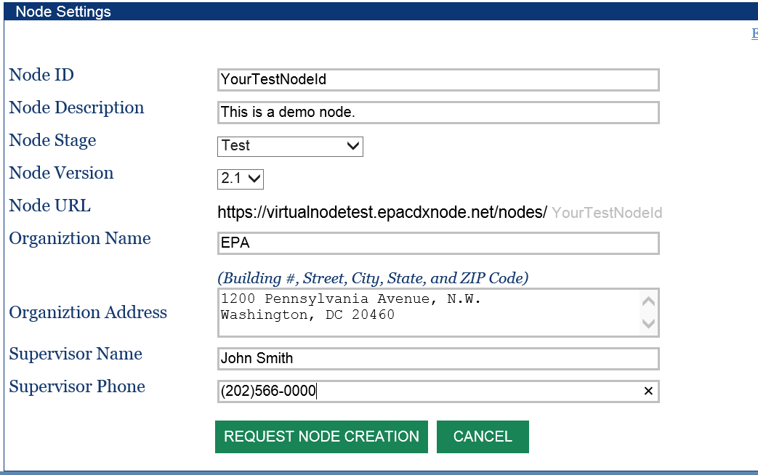

The form contains the following entries

- Node ID: This is a primary identifier of the network node. It should contain only alphanumeric characters without whitespaces. Node ID must be unique and cannot be changed after creation.( e.g. VirginaVirtualNode)
- Node Description: This is a brief description of your node.
- Node Stage: The environment of the node, it can be either ‘test’ or ‘production’.
- Node Version: This is the version of a node. Version 2.1 is the current version and should always be selected unless there are other special reasons.
- Node URL: This is your node address (also referred to as the endpoint). It is constructed automatically based on the hosting environment, domain name and node identifier. It is the address to which all requests to your node should be sent. Please make a note of it.
- Organization Name: The name of your organization. The information is used for node approval and service publishing to the Exchange Network Discovery Services (ENDS).
- Organization Address: This should be the complete address of your organization.
- Supervisor Name and Supervisor Phone: This should be the person in your organization who can be contacted for verification.

After clicking on the “Request Node Creation” button, a new virtual node will be created but marked as ‘Pending’, a message is sent to the Exchange Network helpdesk for approval.

The user who created the node will be assigned as the initial owner (administrator) for the virtual node.

Virtual Node Endpoints

When a virtual node is created, it is automatically assigned an address where SOAP requests are accepted. The address is the node ID prefixed with a base URL, depending on the environment, the base URLs are:

TEST Environment: https://virtualnodetest.epacdxnode.net/nodes
Production Environment: https://virtualnode.cloudapp.net/nodes

For example, if your node ID is MyNode, the production node address would be:

https://virtualnode.cloudapp.net/nodes/MyNode

The URL is case insensitive. The production virtual node and VNAP are hosted in Microsoft Azure cloud environment.

Node Owners and Dataflow Administrators

A node may have multiple owners and each can perform node management tasks independently. The current owner can add additional owners in the Update Node screen as shown below:

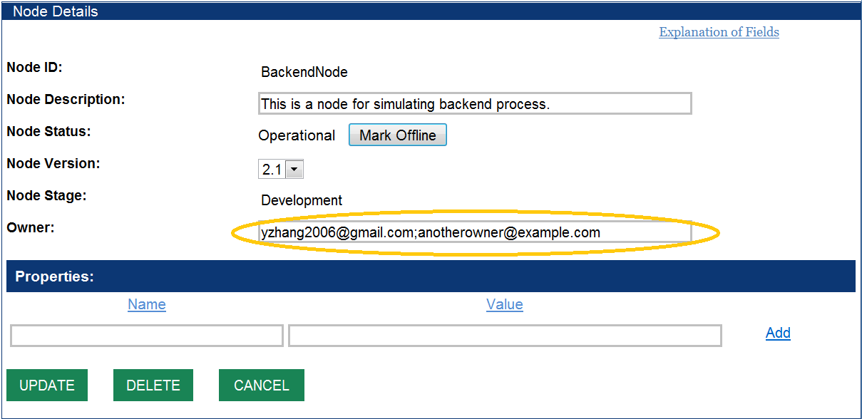

Multiple owners should be separated by semicolons. The new owner must be a node administrator and be authorized by the node helpdesk to manage the node.

A dataflow manager is a special type of administrator that can only manage a particular dataflow on a node using the Create, Update and Delete services under the specified dataflow. A virtual node owner can delegate dataflow management to a dataflow manager. This is only necessary if you want to further delegate dataflow management task to others in your organization, otherwise skip to Section 4.

This is done by granting the flow administrator rights to update services under the dataflow on your node , through a NAAS policy,. For Example, to authorize user@epacdxnode.net rights to update services under dataflow FACID_v30 on virtual node MyNode, the NAAS policy assignment is shown below:

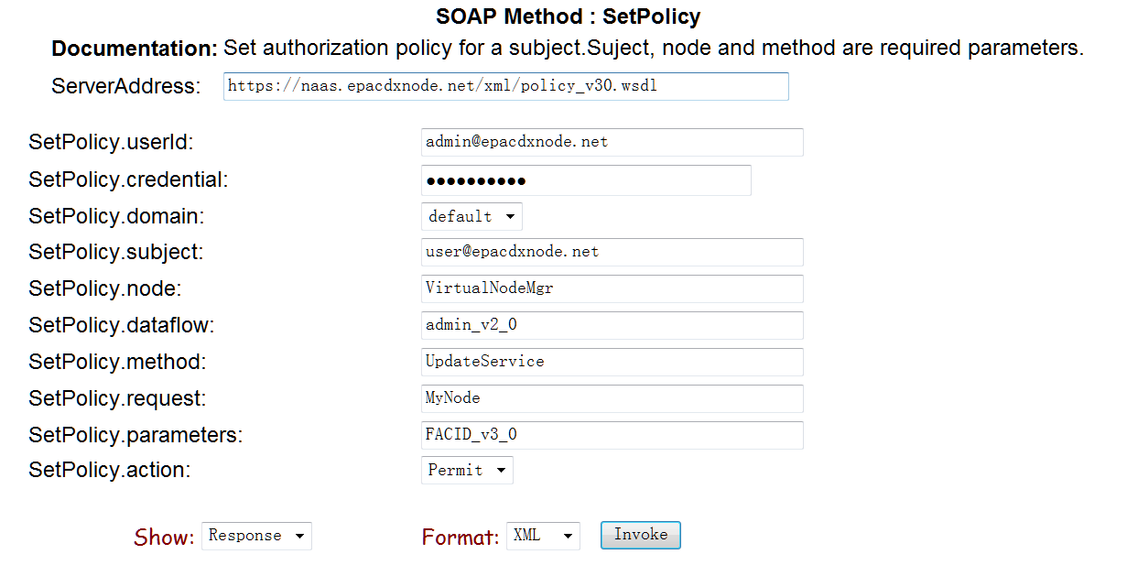

Please refer to the Network Security Specification v3.0 for additional information on NAAS services and definitions.

Data Source Management
In the optimized virtual node architecture, only the network node is migrated to the virtual node in the cloud. The application databases and staging databases can remain in the current enterprise network and have the virtual node connect to them via secure channels. This is the simplest implementation and represents the lowest burden to partners. Alternatively, staging databases could be copied and maintained in the cloud along with the virtual node, but they would still require a data source definition for that location. So, how can your node retrieve environmental information from your local database servers? The Data Source provides the basic information for securely connecting to external databases from your virtual node.

Network Connectivity Options
Before creating a data source, there must be network connectivity from the virtual node to the database server. There are several options available:

- Internet Service Bus: A network agent (or adapter) called the Virtual Node Connector, is provided to relay network traffic between virtual node and your local database server once authenticated. This is the preferred option as the Virtual Node Connector provides secure network connectivity without changing firewall rules.
- VPN: A virtual private network can be setup from the virtual node to your local database server. The connection is secured with key-based authentication and all traffic is encrypted. For the point-to-point tunneling to happen, the database side firewall rule must be adjusted to allow connections from the virtual node. Please coordinate with node helpdesk for VPN connections.
- Azure Connect: Similar to VPN, Azure Connect is a cloud connectivity agent that can be installed on the database server to establish a point-to-point secure virtual network. It is based on IPSEC and all traffic between virtual node and database server is encrypted.

It is the responsibility of a virtual node owner to establish network connectivity. The virtual node engineer and Exchange Network helpdesk will provide assistance as needed.

Create Data Source

A new data source can be created by clicking on the ‘Data Sources’ link on the left panel of VNAP, and then the ‘Add New’ button. A form will be displayed as below:

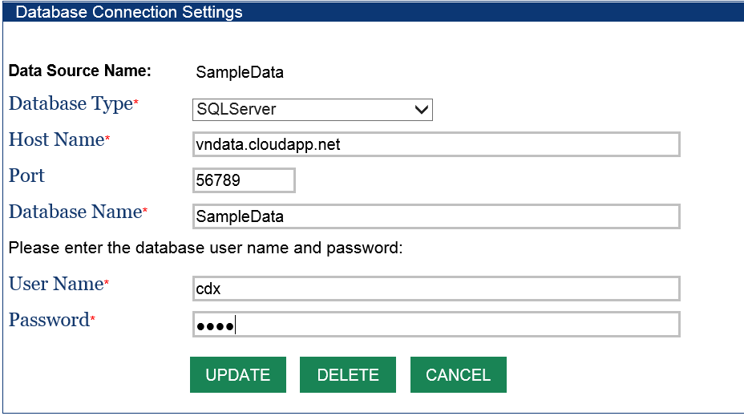

Elements for data sources are:

- Data Source Name: A unique name for your data source, it should contain only alphanumeric characters without any white spaces. The same name will be used in node service definitions.
- Database Type: The type of database servers. Currently supported database servers are SQLServer and ORACLE. Others may be added by request only.
- Host Name: The name of a database server. It can also be an IP address. If the data source is for a remote database with a Virtual Node Connector, please use localhost as the Host Name.
- Port: The database listening port. The default ports for SQL Server and ORACLE are 1433 and 1521 respectively. Please contact your DBA for port information. If the Virtual Node Connector is used, a private database port will be assigned to your database. Please contact yzhang2006@gmail.com if you don’t know your port number.
- Database Name: This is the name of the database for SQL Server. For Oracle, this should be the Service Name, not the SID (Oracle database instance name) – Note: ORACLE service name is case-sensitive. For ORACLE server with Virtual Node Connector, this should be the CID (Oracle System ID) suffixed with the network domain name. For instance, if your CID is dstore and domain is example.com, then the Database Name should be dstore.example.com.
- User Name: This is the user ID for logging on to the database server.
- Password: The database account password. The password will be encrypted on the server.

When the Save button is clicked, an attempt will be made to connect to the database using supplied information. An error will be displayed if the connection failed, and the server stores the data source only when the connection is successful.

Virtual node offers a read-only sample database for node administrators to experiment with. It contains three database tables: Customer, Orders and Product. The connection information is listed below:

Database Type: SQLServer
Host Name: vndata.cloudapp.net
Port: 56789
Database Name: SampleData
User Name: cdx
Password: ******

Data Source Security

A data source, unlike other assets of a node, is dedicated to the node it belongs to, and not shared with other nodes. At runtime, the virtual node engine ensures the data source can only be referenced by the owner’s node.

Database account information is encrypted using a strong algorithm. The runtime engine uses the account information when making a database connection. (only the runtime engine can decrypt this information)

Data sources are your private information. They are not published or disclosed to service registries or anyone else.

Dataflow Management

Dataflow is considered as a collection of the same, or similar, types of information exchanges. In the Node Functional Specification, dataflow is also a container of service definitions, and is a required parameter that must be supplied to Submit, Query, Solicit and Execute methods.

A dataflow must be defined before creating any services. In the VNAP, click the ‘Data Sources’ link on the left panel, and then the ‘Add New’ button on the data source list page. The following HTML form will be displayed:

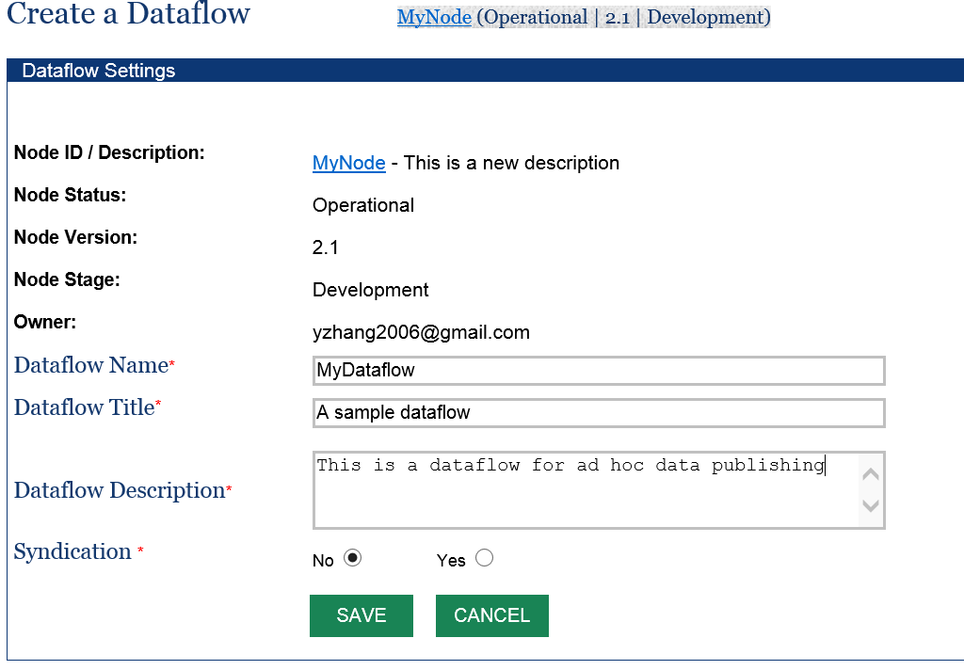

The entries of the form are very simple and straight forward:

- Dataflow Name: This is the name of a dataflow. It must be a unique name in a virtual node, and contain only alphanumeric characters without any whitespaces. Note that the Exchange Network defines standard dataflow names for major data exchanges. Please refer to flow configuration documents on the Exchange Network web site.
- Dataflow Title: This is a short, user friendly name of the dataflow.
- Dataflow Description: This is additional description of the dataflow.
- Syndication: This Boolean value indicates whether transactions of the dataflow should be published as RSS or ATOM news feeds or not. If Syndication is Yes, transactions of the dataflow is published as news feeds at :
https://{virtualNodeDomain}/getnewsfeed?node={nodeId}&dataflow={dataflowName} &token={securityToken}&format=RSS|ATOM
A security token is required for protected services.

Service Management
The Network Node Functional specifications define a very generic and flexible framework for creating new services without changing the node interface and service definitions (WSDL remains the same). There are three main categories of web services an owner can create:

- Incoming Services: Services that allow users to send information to your node. The services are handled by the Submit method and implemented as workflows (based on Windows Workflow Foundation) in Virtual Node. ProcessEISDocument and ProcessFRSDocument are examples of incoming services.
- Outgoing Services: These are services for publishing information to others. Outgoing services are supported by Query and Solicit methods, implemented through a generic database layer with dynamic XSLT transformation or template instantiation in the virtual node. Workflows may also be used for Query and Solicit where ADO (Active Data Object), ADO.NET and Entity Framework are preferred. GetFacilityList and GetServiceList are examples of outgoing services.
- Executable Services: Executable services are mechanisms for adding utility services that are not necessarily related to data submission or data publishing. Executable services are implemented as workflows in the virtual node and are heavily used for scheduled tasks. ExecuteOutboundPooling and RefreshServiceDefinitions are examples of Executable services.
As will be discussed in the following subsections, the virtual node has a set of common workflows that can be reused for processing data submissions so that a node owner can just configure and select the right workflow for incoming services. For outgoing services, the virtual node can publish information as an XML Dataset given an SQL statement. An XSLT style-sheet or a template can then be used to convert the resultant XML into other forms if needed.

Create a Service
To create a Query/Solicit service, you must have two items: a dataflow where the service resides and a data source where the information resides. In VNAP, click on the ‘Services’ link in the left panel and then the ‘Add New’ button on the page, the following page will be displayed for a new service:

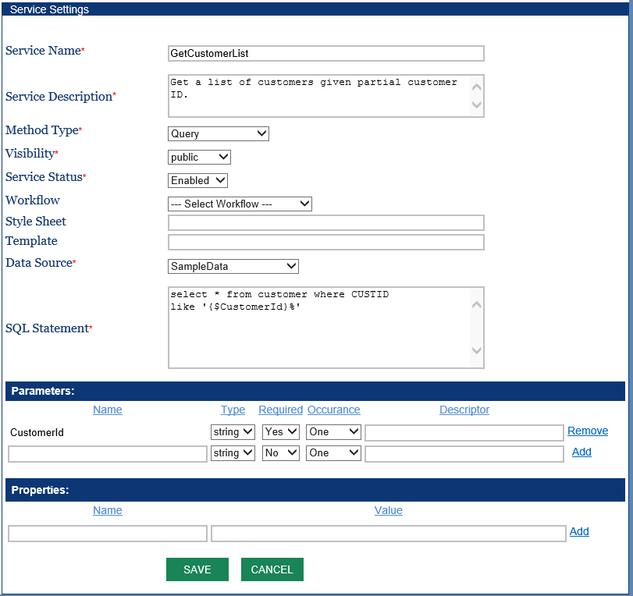

The entries displayed in the form are:

- Service Name: The unique name of a service in your node. It must contain only alphanumeric characters without any whitespaces. We suggest using the camel convention for service names. For example, GetFacilityList and GetServiceDetails are valid service names.
- Service Description: A brief description of the service.
- Method Type: This is the node method under which the service is published. It can be Query, Solicit, Submit or Execute. Select Query for data services.
- Visibility: The scope of the service audience. It can be either public (for public users), protected (for authenticated and authorized users only), or private (unpublished service for authenticated and authorized users only). Authentication is not required on the REST interface when a service is marked public. A private service will not be published to ENDS.
- Service Status: This is a flag that determines whether the service will be accessible or not. It can be either Disabled or Enabled. Virtual node will reject service requests to a disabled service.
- Workflow: This is an optional filename of a workflow (XOML file). The workflow will be executed when a request for the service is received. Virtual node has a powerful default handler for Query and Solicit, so leave this empty if no custom processing is necessary.
- Style Sheet: This is an optional filename of an XLST style-sheet for transforming results. Virtual node constructs a dataset XML document if no style-sheet is supplied, otherwise, it will transform the dataset XML instance document using the supplied file. The parameter is not needed for Submit and Execute services.
- Template: This is a template file for constructing XML instance documents. Virtual node will create XML documents based on the template, which contains data mapping and structural information, instead of the default XML dataset. The parameter is not needed for Submit and Execute service.
- Data Source: This is the name of a data source for the database server (See section 4 ). The entry is required for Query and Solicit services but optional for Submit and Execute services.
- SQL Statement: The SQL query statement to be executed at runtime. A query statement may have parameters wrapped by ‘{$’ and ‘}’. An SQL statement must be supplied for Query and Solicit services but optional for Submit and Execute services. For example, a query service named GetPlaceInfo, which retrieves geographical information of a place, has the following SQL Statement:
select * from USGSNames where statealpha='{$state}' and countyName='{$county}'

As soon as it is created and enabled, the service will be made available to users. You can test the service using any Exchange Network clients or test tools.

To define a service for data submissions, the Method Type should be Submit. The following screenshot shows an incoming service that accepts any forms of document delivered to a virtual node:

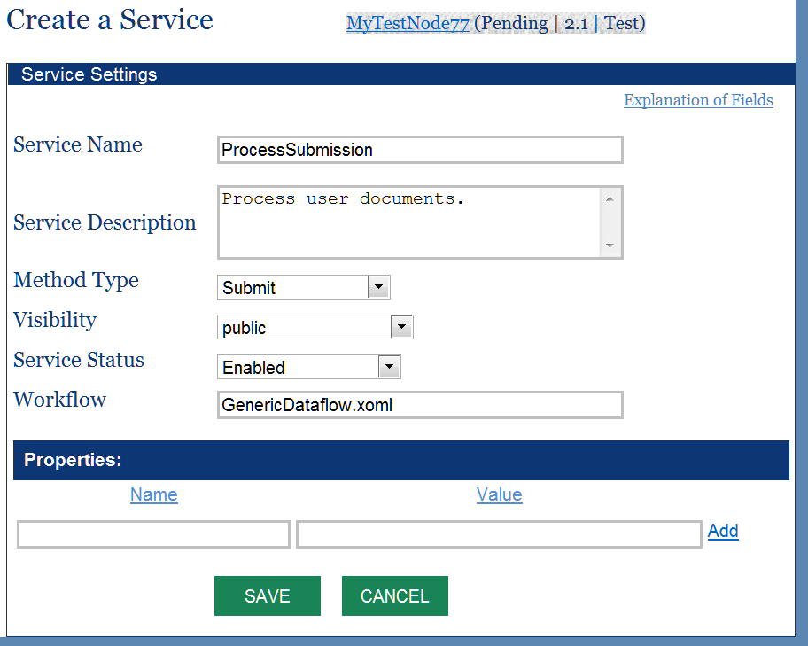

The key element in the service definition is the workflow file name: GenericDataflow.xoml. This workflow performs the following operations when a document is received:

- Create transaction and add audit records.
- Sends a receipt to the submitter.
- Archives the document and extracts the document headers.
- Delivers the payload to a remote backend node if the recipient is a node URL address.
- Notifies recipients of the document availability with transaction information.
- Finalizes the transactions and informs the submitter of the transaction status.

You can basically use the workflow for any dataflow and accept submissions in any format. However, it doesn’t load the payload XML document into a database server. The loading and transforming of data received to a database server is a separate task. Please see Appendix 9.1 for additional workflows and features.

REST Interface

Once a service is created, it is published as a SOAP service and a REST service. The URL template is compliant with the Exchange Network recommendations. It is used for accessing query services as seen below:

https://{virtualnodedomain}/nodedataservice?node={nodename}&dataflow={dataflowname}&request={serviceName}&paramName=paramValue&token={token}&rowId={rowId}&maxRows={maxRows}&format=json|xml

where:
- {virtualnodedomain}: This is the domain name of the virtual node. It may either be virtualnodetest.epacdxnode.net (TEST) or virtualnode.cloudapp.net (PRODUCTION).
- {nodename}: Is the name of a virtual node. i.e., the Node Identifier.
- {dataflowname}: is the name of a dataflow.
- {serviceName}: name of a service.
- All parameters are formatted as name-value pairs separated by &.
- {token}: A security token issued by NAAS. Token is optional for services that are marked as public.
- {rowId}: The starting row ID for fetching the result set.
- {maxRows}: The maximum number of rows to be fetched.
- The result format can be either json or xml.

For example, the GetCountyCode service, shown in section 5.1, would have a REST URL in the TEST environment similar to the following:

https://virtualnodetest.epacdxnode.net/nodedataservice?node=ChrisClarkNode&dataflow=GeoServices&request=GetCountyCode&state=Virginia&format=json

Clone Services
To further simplify creation of services, the Virtual Node administrator interface provides a utility for copying services from other nodes. You can clone all services under a dataflow, or just a single service from another node.

To access the tool, click on the ‘Import Configurations’ link, the following screen will be displayed:

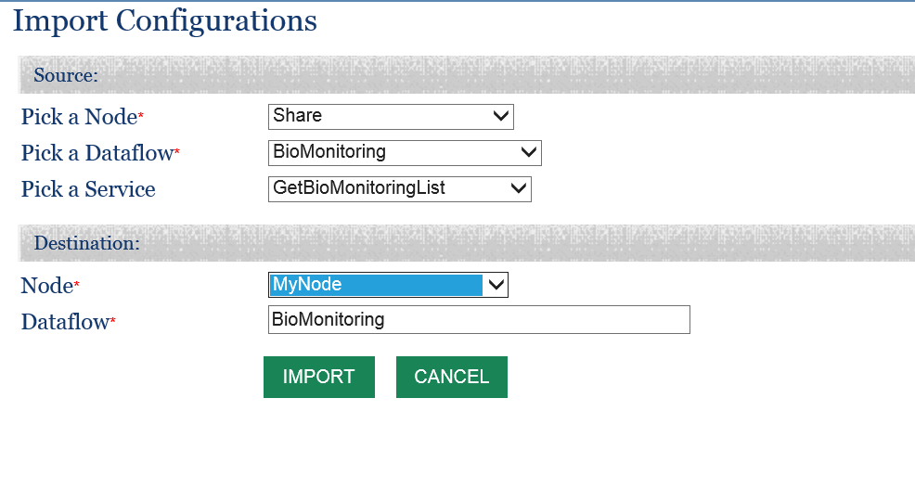

Please select a source node, dataflow and a service name from the dropdown boxes, and then click the IMPORT button. The service will be copied to your node. If the name of a service is not selected from the source node, the tool copies all services under the dataflow. Note that the clone utility will not copy Data Sources from the source node for security reasons, the copied services need to be edited to use your own data source.

Publish Services
The virtual node is fully integrated with the Exchange Network Discovery Services (ENDS). It supports both the push model (submit service definitions) or the pull model (GetServices from ENDS). However, pulling occurs on a scheduled basis at night. The owner of a virtual node can make services visible immediately by publishing them from VNAP.

In order to publish node services into ENDS, you must be specifically authorized to load service definitions for a particular node. This is to prevent the administrator of Node A from changing service definitions of Node B. Please contact the node helpdesk at nodehelpdesk@epacdx.net for help setting up the publishing of services.

After logging on to VNAP, the node dashboard will be displayed as shown below. The “Publish Service” link will be available if a node is enabled (not pending), and has a dataflow with at least one service under it. Clicking on the link will trigger submission of service definitions to the ENDS server.

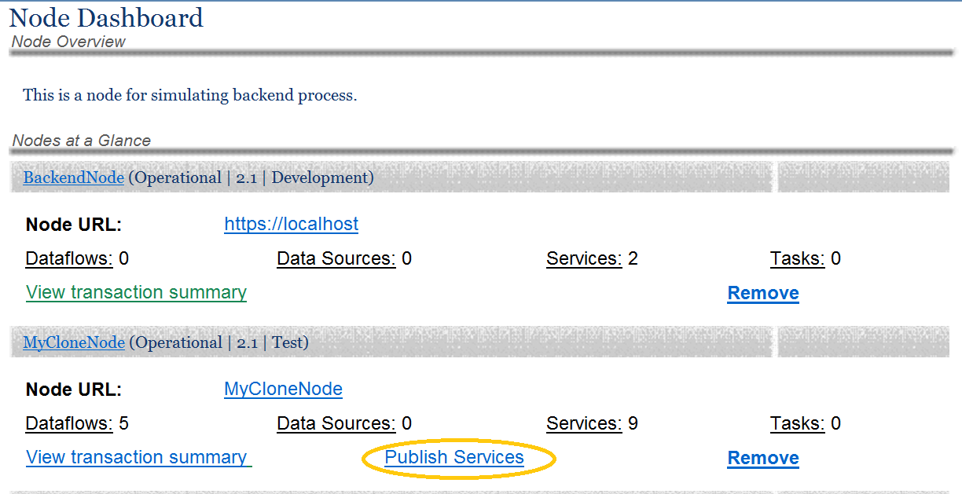

Update Services

It may be necessary to make changes to your service definition after it is created. This is done by selecting Services on the left panel and then clicking on the service to be modified. The service detail screen, similar to the screenshot below, will be displayed:

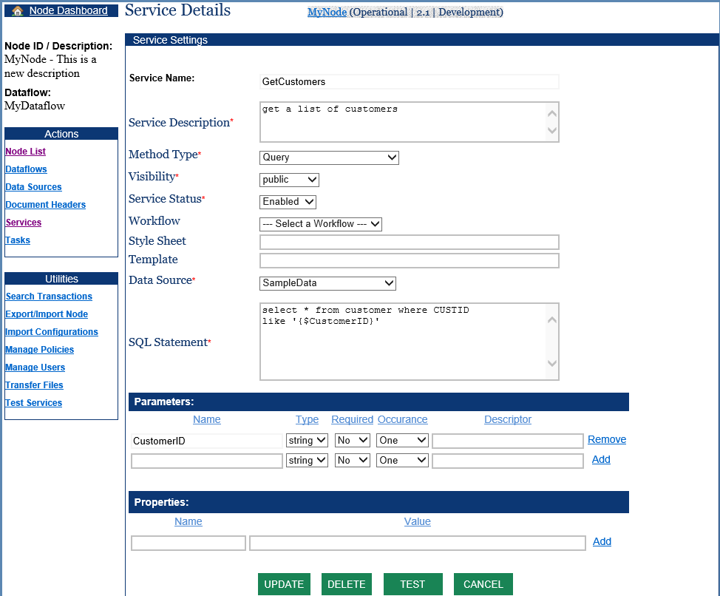

The most frequently changed item on the screen is the SQL Statement. If the statement is complex, it is a good idea to cut and copy it to a SQL editor where it can be changed and tested. But you should remember to copy it back here and click the Update button for it to take effect!

Task Management
A task is a scheduled operation that is executed by virtual node runtime engine. Tasks are commonly used to automate routine works. In virtual node, a scheduled task is always associated with an Execute service. When a task is triggered, the service will be executed.

A task can be created by clicking on the ‘Tasks’ link on the left panel of VNAP. A screen similar to the following will be displayed:

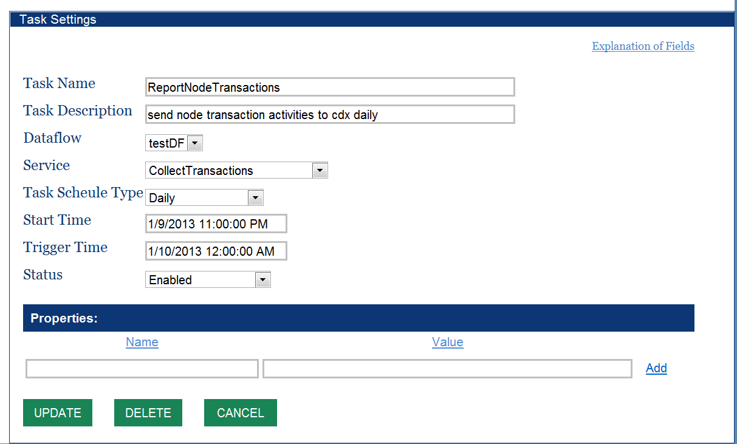

The entries on the task form are explained below:

- Task Name: A unique name of the task. This should contain only alphanumeric characters without any whitespaces.
- Task Description: A brief description of the task.
- Dataflow: This is the name of an existing dataflow defined in the node.
- Service: The service to be executed. It should be a service for the Execute method.
- Schedule Type: This is the frequency of task execution. It can be Yearly, Quarterly, Monthly, Daily, Hourly or Minutely.
- Start Time: This defines the starting boundary of the task.
- Trigger Time: This is time when the task will be executed.
- Status: This is a Boolean flag to enable or disable the task.
- Properties: A list of properties of the task. The properties are usually passed as parameters to the service.

The example task shown above retrieves a list of transactions, constructs an XML document and Submit to CDX at midnight (12:00AM).

When a task is triggered, the virtual node creates a transaction associated with service execution so that it can be audited and verified.

IMPORTANT: If your service uses other web services that require authentication, then UserId and Credential (password) properties must be provided as the task will be running without human intervention. The following screenshot shows an example where user account information is supplied in the service property:

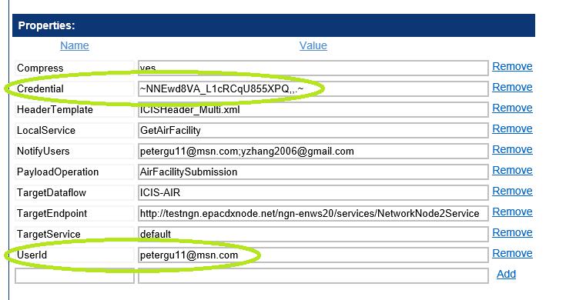

The password (Credential) is automatically encrypted by the virtual node.

Document Headers
Many of the Exchange Network dataflows require a document header for submissions. The virtual node offers a table to store document header information for each dataflow, and uses the header information when constructing instance documents.

A document header can be created by clicking on the “Document Headers” link in the left panel of VNAP, and then the “Add New” on the document header list page. The following screen will be displayed:
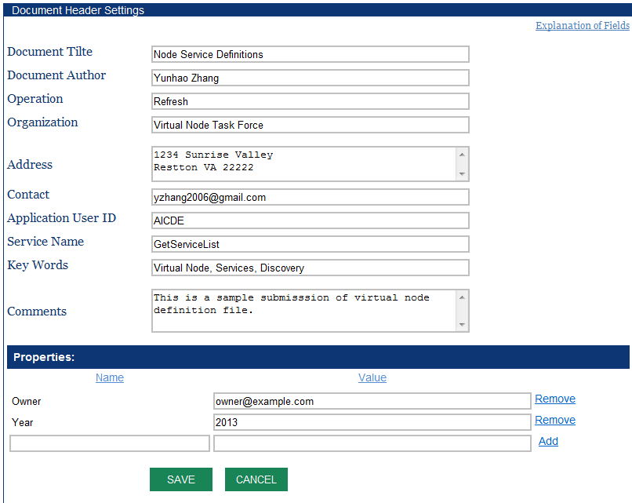

Entries on the forms are very straightforward. Please refer to the Exchange Network Document Header Specification if you need additional information.

Once the header is saved, it can be used to create either version 1.0 header or version 2.0 header during the process of constructing an XML payload. Virtual Node supplies a header template file which will be populated using the information supplied here.

A custom header template could also be used. This is done by adding a HeaderTemplate property with the name of the template file in the service definition.

Transfer Files to Virtual Node

A node administrator can transfer files, such as schemas, style-sheets or templates to the virtual node.

Under the Utility Section in the left panel of VNAP, clicking on the ‘Transfer File’ link, the file transfer form will be displayed:
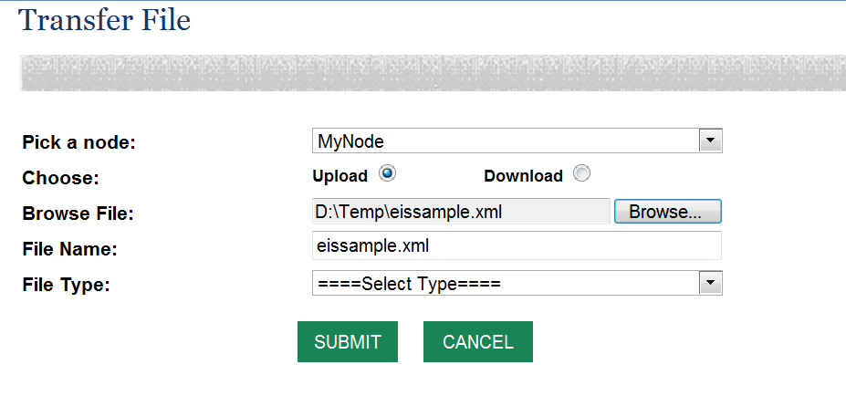

You need to select the node to transfer to/from, and choose a file from the local computer. The File Type parameter is optional; it is actually the folder name for organizing files under a node.

Appendix

Information Exchange Patterns and Common Workflows
The virtual node leverages a powerful workflow foundation technology for orchestrating complex business processes from a very high level. The virtual node workflows are constructed by dragging and dropping activities (work units) using a graphical designer, just like building a Lego figure using blocks.

To further simplify dataflow development, the engineering team has constructed a set of common workflows based on typical data exchange patterns in the Exchange Network. These abstracted business processing makes it possible for node owners to use dataflows and services without a single line of coding.

The following subsections describe existing workflows, what they do and when to use them. We welcome suggestions for new assembly of workflows for common application patterns. Please contact the Node Help Desk with your business case and requirements; we will create new workflows as needed.

Basic Submission Workflow

Description
This is a very general workflow which allows submissions of data to any dataflow in any format. The workflow name is BasicSubmit.

Operations
The workflow performs the following operations:
- Create transaction and add audit records.
- Send receipt email to the submitter.
- Archive the document and extract document headers.
- Deliver the payload to the remote backend node if the value in recipient is a node URL address.
- Notify recipients of the availability of the document with transaction information.
- Set transaction status to “COMPLETED”
and inform the submitter of the new status of the transaction.

Parameters
None.

Usage
The workflow can be used in situations where data validation is either unnecessary or infeasible (non-XML). The payload of data submissions may have undetermined format. The workflow that is selected from the drop down list on the service form is BasicSubmit.

Variants
- Submission service for loading TRI data from CDX. The workflow name is ProcessTRIDoc. It can handle different dataflow, TRI.

- Submission service for loading SPCC data. The workflow name is ProcessSPCCData. It can handle different dataflow, SPCC.

- Submission proxy. The workflow name is SubmissionProxy. It forwards submission to CDX or other node.

Generic Submission Workflow with Validation

Description
This is a workflow that not only handles the regular submission processing, but also tries to validate the document using the QA services. The workflow name is GenericSubmit.

Operations
The workflow performs the following operations:

- Creates a transaction and adds audit records.
- Sends a receipt to submitter.
- Archives the document and extracts the document headers.
- Validates the document using the QA services, terminates the transaction if validation fails, otherwise proceeds to next step.
- Delivers the payload to remote backend node if the recipient value entered in the form is a node URL address.
- Notifies the recipients of the availability of the document including the transaction information.
- Finalizes the transactions and informs the submitter of the status of the transaction.

Parameters

Usage
The workflow can be used for processing XML submissions where schema or schematron data validation is necessary.

Generic Query

Description
This workflow invokes a Query service on a virtual node and then transform to XML document with specific XML schema defined with dataflow. The workflow name which is selected from the drop down list on the service form is GenericQuery. This query service utilized ODBC database connectivity, and has limitation of ODBC. For more complicate query with SQL scripts, ADOQuery in next section can be used.

Operations
The workflow performs the following operations:

- Invokes the Query service against a virtual node.
- Transform query results into a strong typed XML file, either complied with specific XML schema defined in dataflow or exchange network dataset.

Parameters
- User defines query parameters based on query conditions in service configuration UI.

Usage
The workflow can be used for delivering your database information to another network node in XML.

Generic Query with ADO.Net

Description
This workflow invokes a Query service on a virtual node and then transform to XML document with specific XML schema defined with dataflow. The workflow name which is selected from the drop down list on the service form is
ADOQuery. It can handle complicated query with SQL scripts.

Operations
The workflow performs the following operations:

- Invokes the Query service against a virtual node.
- Transform query results into a strong typed XML file, either complied with specific XML schema defined in dataflow or exchange network dataset.

Parameters
- User defines query parameters based on query conditions in service configuration UI.

Usage
The workflow can be used for delivering your database information to another network node in XML.

Local Query and Submit

Description
This workflow performs a database query operation against the local node and then submits the resultant XML document to a remote node. The workflow name that is selected from the drop down list in the service form is QueryThenSubmit.

Operations
The workflow performs the following operations:

- Performs the database query and retrieves result set.
- Constructs an XML instance document.
- Submits the XML document to the target node, retries at least three times if failures occur.
- Finalizes the transaction status.
- Notifies the owner of the status of the transaction.

Parameters

Usage
The workflow can be used for delivering database information listed in your data sources to a remote node.

Variants
There are a couple of specialized workflow based on QueryAndThenSubmit. They are:

- SubmitAQSData : The workflow is customized for supporting AQS, WQX, OWIR-ATT and others. It performs a local query operation (constructing an XML instance document), submitting to a target Network Node and then download processing report.
- SubmitMultiICISPayload: It is specifically designed for ICIS-AIR data submissions, which performs a local query, data submission, backend report processing.

Generic Solicit

Description
This workflow handles solicit request to the node. It performs specified database services in an asynchronous mode and then updates transaction status as needed. The workflow name that is entered into the service form is GenericSolicit.

Operations
The workflow performs the following operations:

- Performs the database query and retrieves the result set.
- Constructs an XML instance document.
- Updates the transaction status (Completed or Failed).
- Notifies the user about the status of the transaction.

Parameters

Usage
The workflow can be used for processing any Solicit requests.

Solicit and Download

Description
This workflow invokes the Solicit method on another node. It then checks transaction status and downloads the result file when available. The workflow name that is entered into the service form is FetchNodeData.

Operations
The workflow performs the following operations:

- Invokes a Solicit service from a network node.
- Checks the status of the transaction.
- Downloads the document form the remote node when ready.
- Notifies the user of the status of the transaction.

Parameters

Usage
The workflow can be used for retrieving large payloads from another network node.

